SQL
Session-4
1.Create a table called Playlist with columns: id, song_name, artist, genre, and play_count. Insert at least 5 sample records representing your favorite songs from Spotify.

CREATE TABLE Playlist (
id INT PRIMARY KEY AUTO_INCREMENT,
song_name VARCHAR(100),
artist VARCHAR(100),
genre VARCHAR(50),
play_count INT
);

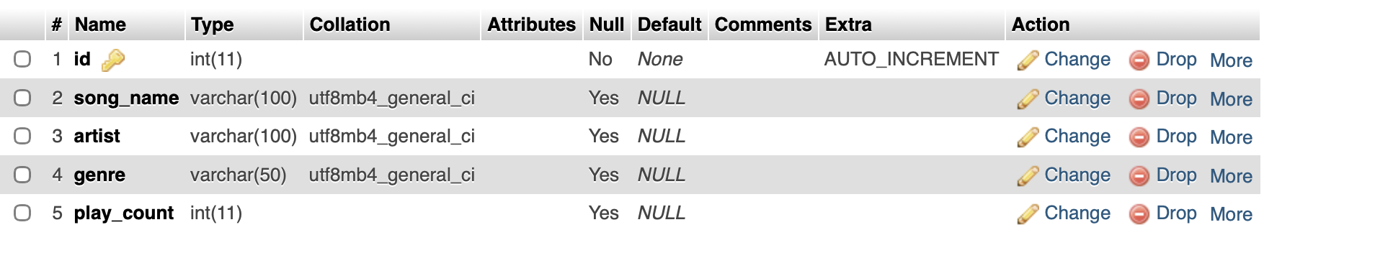

INSERT INTO Playlist (song_name, artist, genre, play_count)
VALUES
('Kesariya', 'Arijit Singh', 'Pop', 150),
('Tum Hi Ho', 'Arijit Singh', 'Pop', 250),
('Blinding Lights', 'The Weeknd', 'Pop', 180),
('Godzilla', 'Eminem', 'Hip-Hop', 220),
('Lose Yourself', 'Eminem', 'Hip-Hop', 130);

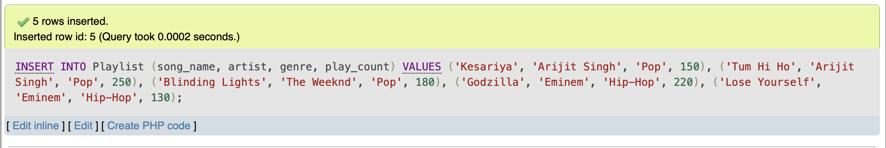

2.Write a SELECT query to display only the song_name and artist from the Playlist table, but show the artist column as 'Singer' using an alias.

SELECT song_name, artist AS Singer
FROM Playlist;
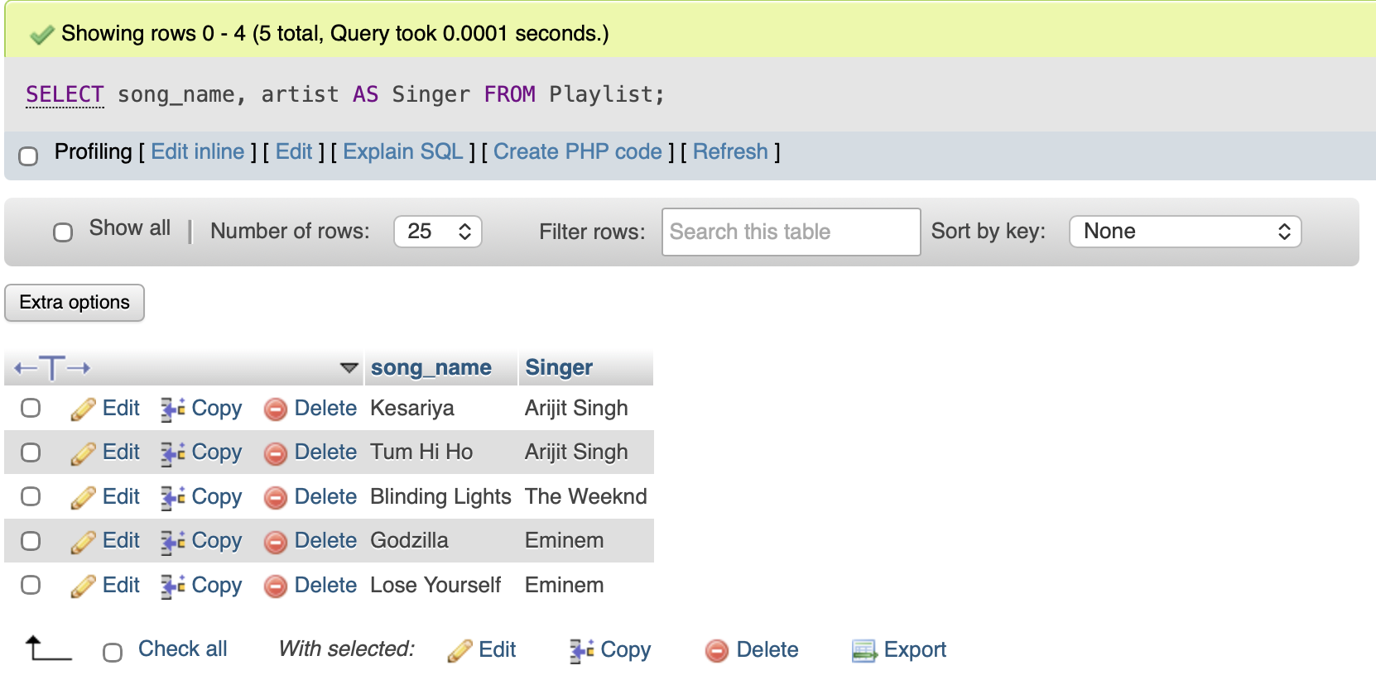

3.Write a SELECT query to find all songs in the Playlist table where the genre is 'Pop' and play_count is greater than 100. Sort the results by play_count in descending order.
SELECT *
FROM Playlist
WHERE genre = 'Pop'
AND play_count > 100
ORDER BY play_count DESC;
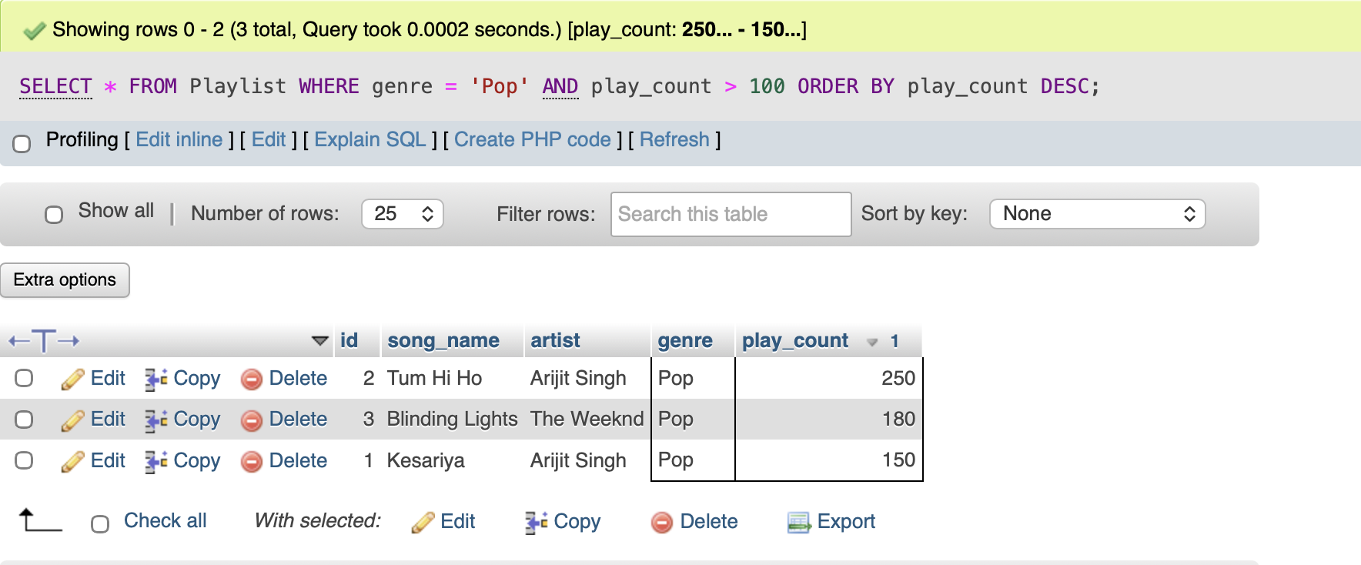

4.Use the COUNT aggregate function to find out how many songs in your Playlist table belong to the genre 'Hip-Hop'.
SELECT COUNT(*) AS HipHop_Songs
FROM Playlist
WHERE genre = 'Hip-Hop';
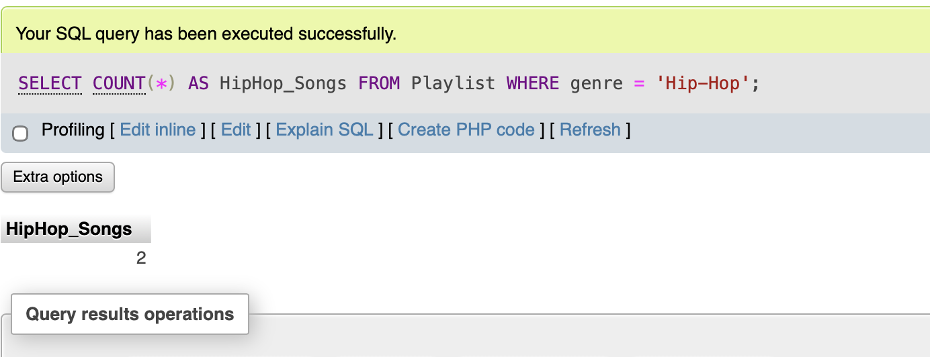

5.Write a SELECT query that shows the total number of plays (SUM of play_count) for each genre in your Playlist table, grouped by genre.<br><br><em><strong>Hint:</strong> Use GROUP BY with the SUM function to aggregate play counts by genre.</em>
SELECT genre, SUM(play_count) AS Total_Plays
FROM Playlist
GROUP BY genre;
